**JS basics**

**Alzero js playlist (1-85)**

**#var , const ,let**

**Note : const,let in ES6**

# \ Escape

#Concatination

#Templeat Literals (template String )

We make the string template by using Backticks ``

قبل ال

Es6

كانت فكرة انو اعمل نص مكون من اكثر من سطر تحتاج استخدم

Concatenation +

واذا بدي استخدم مثلا احدي االرموز الخاصة " اضطر اعملها

Scape

فالموضوع كان معقد شوي

فال es6

جابت اشي اسمه

String literals

ليسهل فكرة انشاء نص من اكثر من سطر

مقارنة نفس الكود ياستخدام

String template

وبدونه

#Arithmetic operators

#Assigment Operator

#Number Method

Two dot to call amethod

اذا استخدمنا نقطة واحدة الكومبايلر حيعتبر اللي بعدها كانه منازل عشرية وهاد خطا لهيك نضيف نقطتين لاستدعاء الدالة لالخاصة بال

number

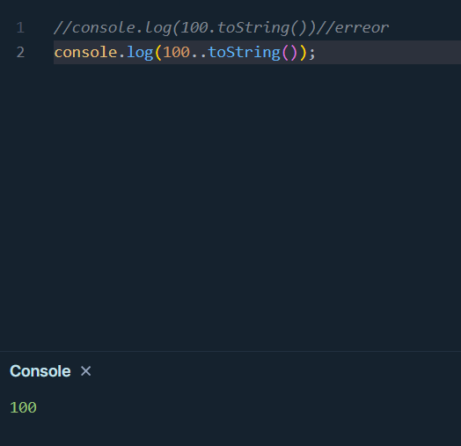

parseInt()

اذا كتبنا داخله اول شي عدد وبعدها سترنج بيشوف العدد بس وبطبعه لكن لو كتبنا العكس سترنج وبعدها عدد اول ما حيشوف السترنج فحيرجع

NAN

#Math methods

#String Methods

Slice,substr => بتفهم انواذا حطيت الاندكس سالب يعني انو تبلش عد من اخر النص

Slice=> have more than one case

Take positive index or negative index =>

Take the start index only and the end index automatically will become to the string end .

Take the start and end index

Substr()=> have more than one case

Take positive index or negative Index =>

Take the start index only and the end index automatically will become to the stringEnd .

Take the start index and the length of the substring

substring()=> اذا حطيت الاندكس سالب حتعتبر انه صفر ما بتبلش تعد من اخر النص

Take positive index =>

Take the start index only and the end index automatically will become to the string end .

Take the start and end index

Take negative index => the negative index mean 0

#Comparison Operator

#Logical Operator

# if Conditions

Ex:

#Swich conditions

#Array

Array Method

Output:

Line12=>0

Line13=>-1

Line15=>4

Line16=>0

Line18=>true

Line19=>true

Concat() join all array in one array and return it

Join() join the array in one string with (, )sperator by default or another sperator , return string .

#Loops for ,while,do while

Loop label

انو بحط مثلا للوب الخارجي اسم والنيستيد اسم وداخل اللوب الداخلي بعمل بريك من اللوب الخارجي

Ex:

#Functions

Function with reset parameter

Reset parameter is aparameter with array type declear using three (.),using when we don’t know the parameter count which function take it .

#Anonymous FunctionA computer screen with text

AI-generated content may be incorrect.

بنستخدمه لما بدنا نعمل فنكشن نريد استخدامها لمرة واحة ما بتتكرر يعني مثلا بدنا لما المستخدم يضغط على زر ما ينفذ دالة معينة هون ما بلزم نعطي اسم للدالة شو الهدف من الأسم!!و كمان

High order function ()

بتاخذ دالة كبراميتر فهون بعمل

Anonymous Function

بدون اسم .

#Hight Order Function

map(),filter().reduce(),foreach() video(71-78) jsElzero

# Object

Object is structure consist from property and methods

Ex:

person is object hase property as name ,age ,Birthday…, and make methods as sleep,work,play ets ..

To access the object property if the property identifier without "" we can use dot notation or Bracket notation, but if the property identifier using "" we can access it by using only the brackets Notation.

The best practices is using the Dot Notation with the valid Property .

## Nested Object

##add new property to exist object

2 method :

1-using Dot Notation .

2-using brackets Notation.

## create objext using new keyword

#This keyword

